Adhelia Iranezereza
Applied Studies 2
Logbook
Peter McDevitt
January 14-17

Journal Week1
Task ID: #3005
Location: E1019
Date: 14/01/2025
Start Time: 8:30 AM
End Time: 11:30 AM
Time Billed: 3 Hours @ $ 75.00/hr =$ 225
Work Description: configured the routers with the appropriate interfaces into our ports and IP addresses.

Task ID: # 3006
Location: E1019
Date: 15/01/2025
Start time: 1:30 PM
End Time: 3:30 PM
Time Billed: 2 hours @ $ 75.00/hr = $ 150
Work Description: Install and configure Physical Hosts
Details: windows host configured with Windows 11 in the mode with the name of device T3Win1, an IP 192.168.143.25/24, GW 192.168.143.1, DNS 8.8.8.8. Once I was done, I restarted the device and the date, time, and zone were done.

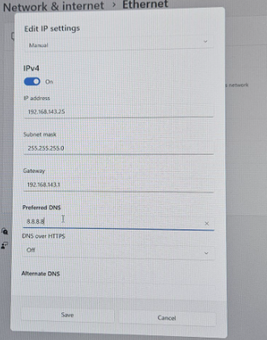

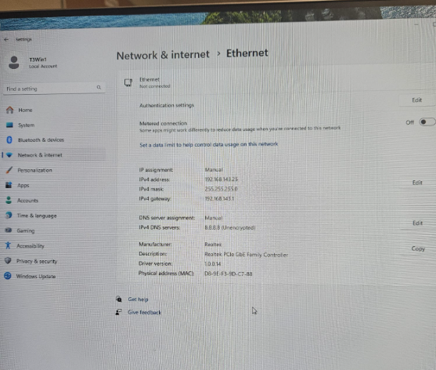

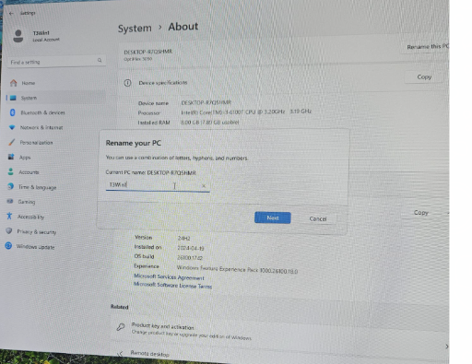

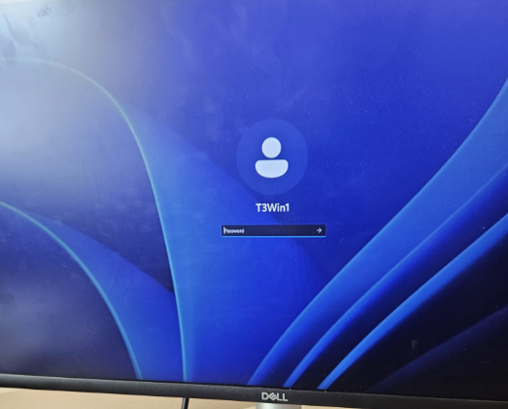

Task  ID | Date | Start Time | End Time | Hours | Rate | Costs
A1 | 14/01/2025 | 8:30 AM | 11:30 AM | 3 hrs | $75.00 | $ 225
A2 | 15/01/2025 | 1:30 PM | 3:30 PM | 2 hrs | $75.00 | $ 150
 |  |  | Totals: | 5 hrs |  | $375
 |  |  | Total After  Taxes (15%) |  |  | $431.25

